**1. Multi-tasking :**   
Multi-tasking is the logical extension of multiprogramming. In this system, the CPU executes multiple jobs by switching among them typically using a small time quantum, and these switches occur so frequently that the users can interact with each program while it is running. Multitasking is further classified into two categories: Single User & Multiuser.

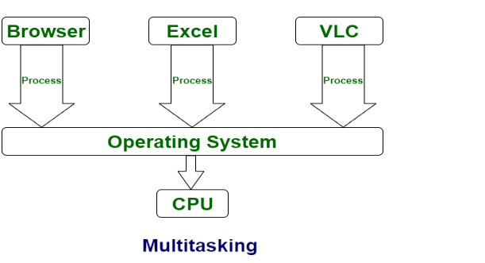

**2. Multiprocessing :**   
Multiprocessing is a system that has two or more than two processors. In this, CPUs are added for increasing computing speed of the system. Because of Multiprocessing, there are many processes that are executed simultaneously. Multiprocessing is further classified into two categories: Symmetric Multiprocessing and Asymmetric Multiprocessing.

